UPWARD LIGHT-RING PCB

- PARTS:

QUANTITY: PART #: NOMENCLATURE:

88 PER PCB (88 PER MACHINE) 18721- LED, HIGH POWER, WIDE ANGLE

1 PER PCB (1 PER MACHINE) 17550-2 HEADER, RT. ANGLE, 2-PIN

8 PER PCB (8 PER MACHINE) 15343- RESISTOR, CARB FILM, ¼ W, 620 OHM-5%

1 PER PCB (1 PER MACHINE) 217073- PCB, BLANK, RING OF LIGHTS

- ASSEMBLY:

- PLACE THE EIGHT RESISTORS IN THE LOCATIONS MARKED”R-“ AND SOLDER THEM IN, ACCORDING TO DIAGRAM 1.

NOTE 1
THE BLUE STRIPE SHOULD BE TOWARDS THE RIGHT ON HORIZONTALLY MOUNTED RESISTORS. THE BLUE STRIPE SHOULD BE TOWARDS THE TOP ON VERTICALLY MOUNTED RESISTORS.

- PLACE THE ONE HEADER IN THE LOCATION MARKED “+24V – GND” AND SOLDER IT IN, ACCORDING TO DIAGRAM 1.

NOTE 2
IF THE “+24V” REFERENCE IS BELOW THE HEADER, IT IS INCORRECT. THE 24V AND GND REFERENCES ARE BACKWARDS. KEEP THIS IN MIND WHEN YOU ARE CONNECTING THE POWER CABLE TO IT.

- PLACE THE EIGHTY-EIGHT LEDS IN THEIR LOCATIONS AND SOLDER THEM IN, ACCORDING TO DIAGRAM 1.

NOTE 3
THE POLARITY OF THESE LEDS IS CRITICAL. BE SURE THAT THEY ARE PLACED ON THE BOARD ACCORDING TO DIAGRAM 1.

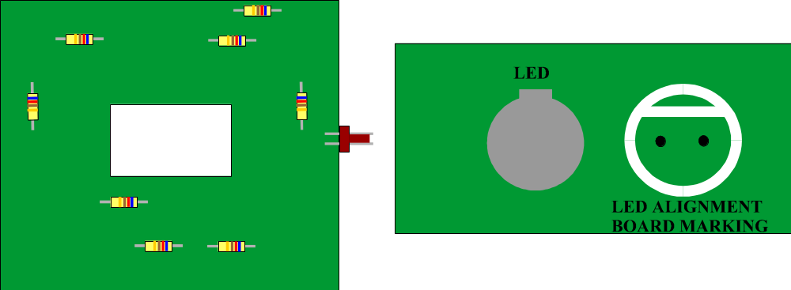

DIAGRAM 1

